INFORMATICA INTELLIGENCE CLOUD SERVICE
DATA MODELLING DESIGN
TEAM: RUNTIME REBELS
SCENARIO: This pipeline helps telecom teams analyze customer usage, detect high usage, and process daily call data automatically.

- Conceptual Data Model
• Identify core entities
• Define relationship

Core entities:
1 dim_cust 2 dim_time 3 dim_tower 4 dim_calltype
Relationships:
DIM
FACT
|────── ───────<

2. Logical Data Modelling
• Define tables + columns
FACT TABLE: FACT_CALL
Columns:
- Call_ID (PK)
- Customer_Key (FK)
- Tower_Key (FK)
- Time_Key (FK)
- CallType_Key (FK)
- Duration
- Revenue
- Is_International

3. Physical Data Modelling
•Actual tables in database
•Column data types
•Constraints (PK, FK, NOT NULL, UNIQUE)
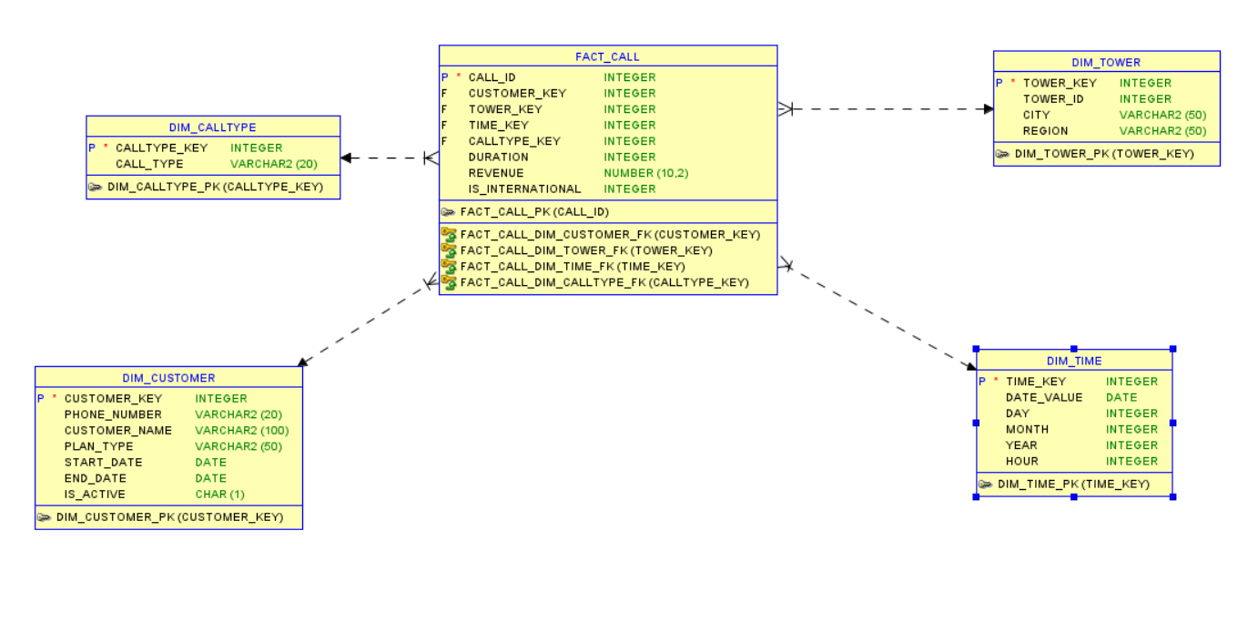

WORKFLOW
SOURCE TABLES WITH UNCLEANED DATA AND MIXED TYPES

RAW DATA TABLES
LOAD DATA
DIM_time

ETL: STAR SCHEMA TRANSFORMATION
Lookup Surrogate Keys from DIMs, Join Cleansed Tables. , Aggregate Measures & Metrics.

Fact call

DIM_cust

TECHNICAL STAGING & KEY SETUP
Generate Sequences: Initialize IICS SEQ for future Surrogate Keys .KPI Identification: Isolate Measures (Facts) from Attributes (Dims)

ORACLE – STAGING AREA

DIM_calltype

CLEANING AND DIMESNSION LOADING
[Sidebars are great for calling out important points from your text or adding additional info for quick reference, such as a schedule.
They are typically placed on the left, right, top or bottom of the page. But you can easily drag them to any position you prefer.
When you’re ready to add your content, just click here and start typing.]

DIM_tower

FINAL WAREHOUSE LOADING
Batch Load to Production Schema., Rebuild Indexes & Constraints.

OLTP SYSTEM

DATAMART
1.DAILY CALLVOLUME SUMMARY
2.CALLTYPE PERFORMANCE ANYSIS
3.INTERNATIONAL CALL MONITORING
4..REVENUE DATA
Select required business-specific data from Data Warehouse
DATA WAREHOUSE

BI TOOLS / REPORTING
Generate dashboards, reports, and visualizations
OLAP SYSTEM

STAGING RAW TABLES:

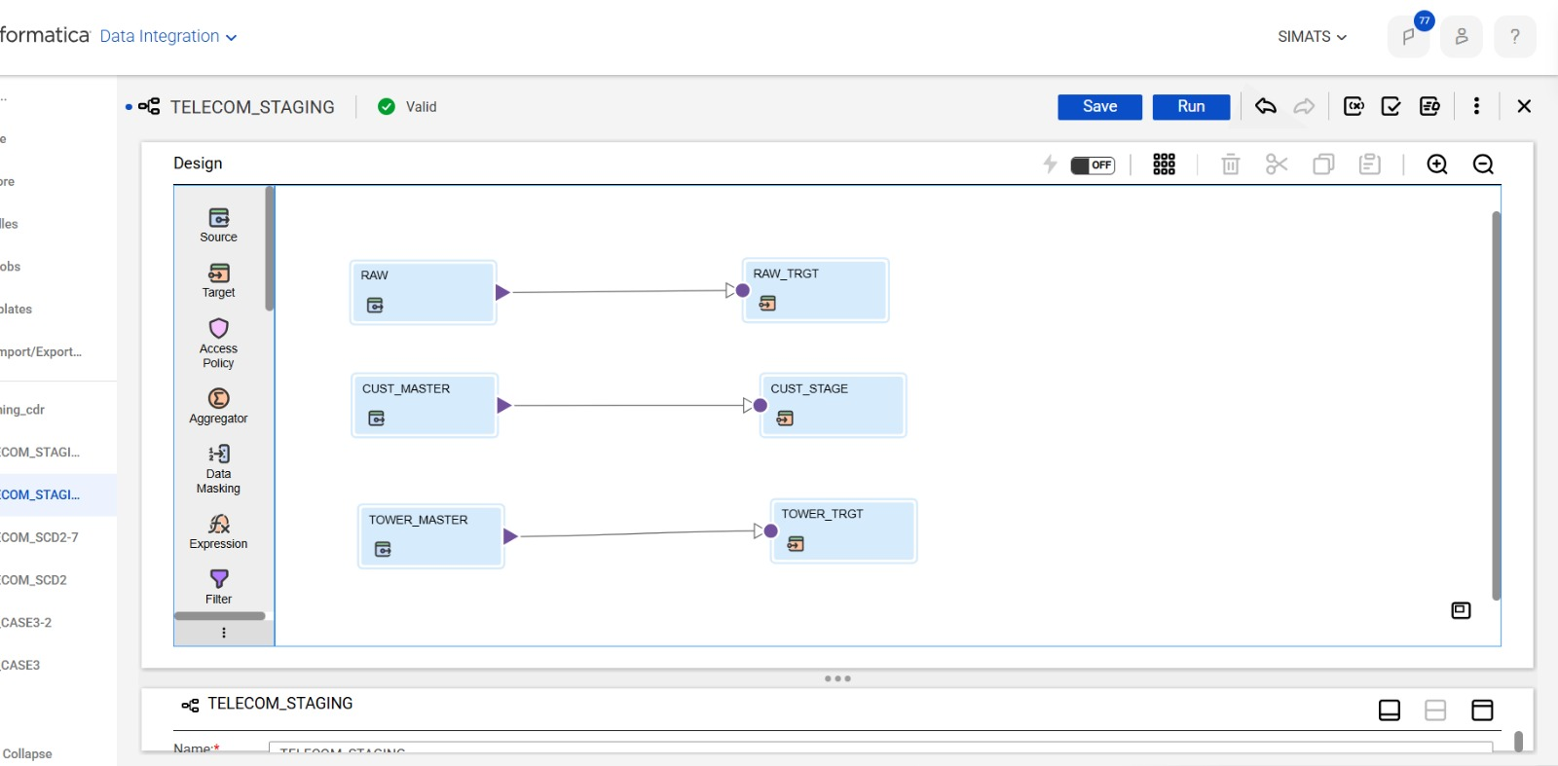

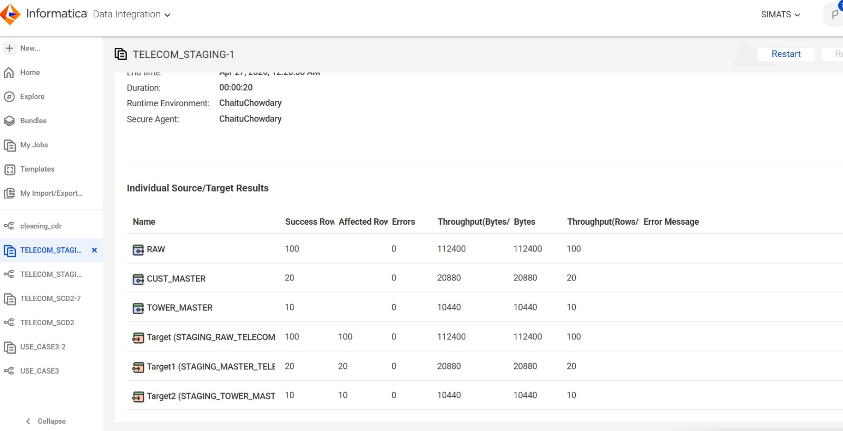

CLEANING:
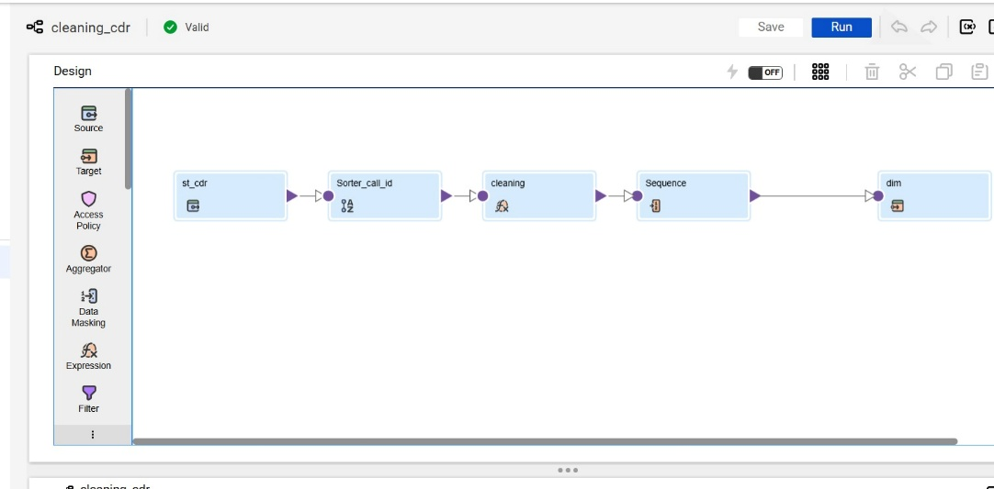

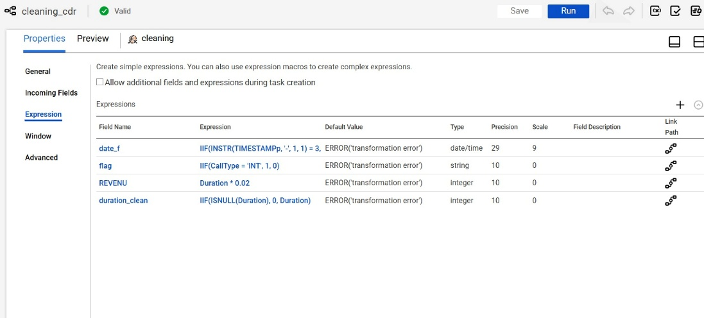
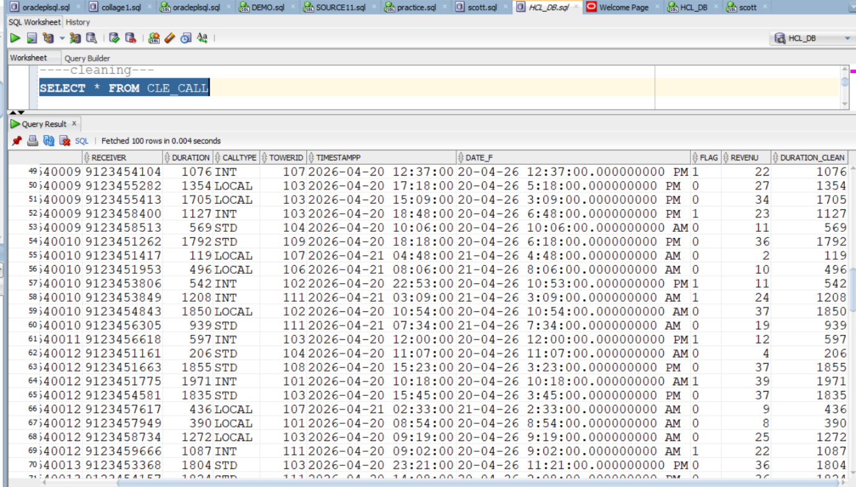
DIM_TABLES:
DIM_TIME:
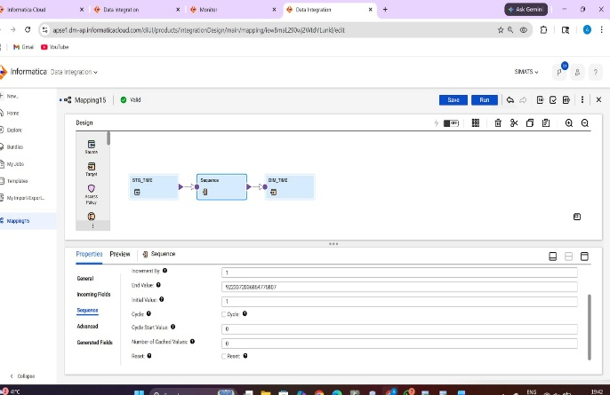
DIM_CUSTOMER:
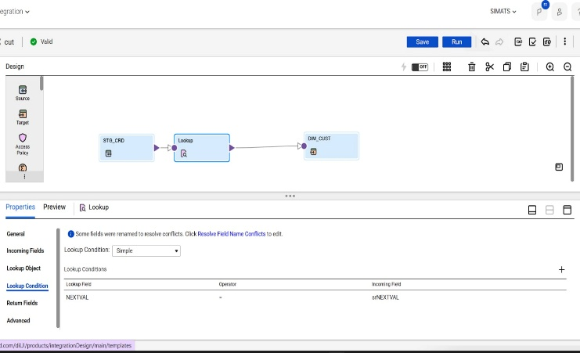
DIM_TOWER:
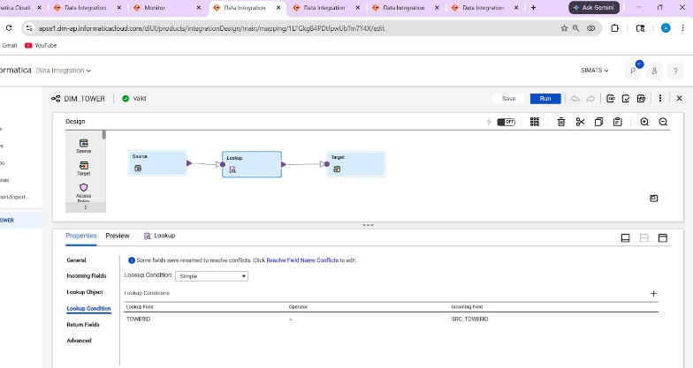
DIM_CALLTYPE:
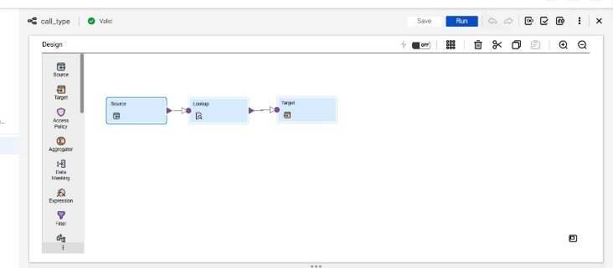
FACT_TABLE:
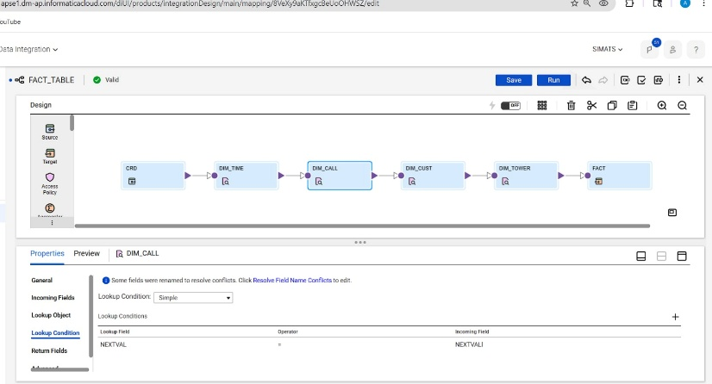

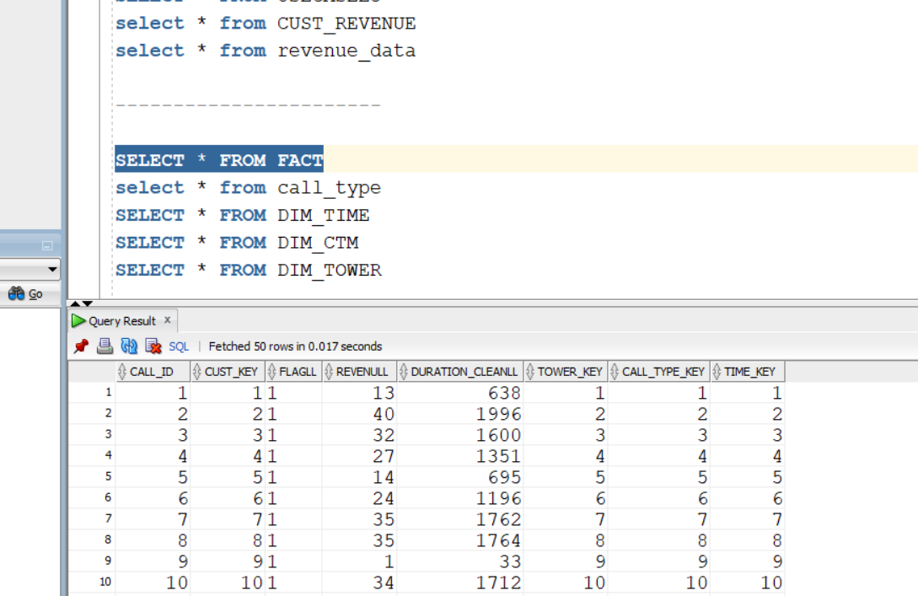

SCDTYPE2 – DIM_CUSTOMER
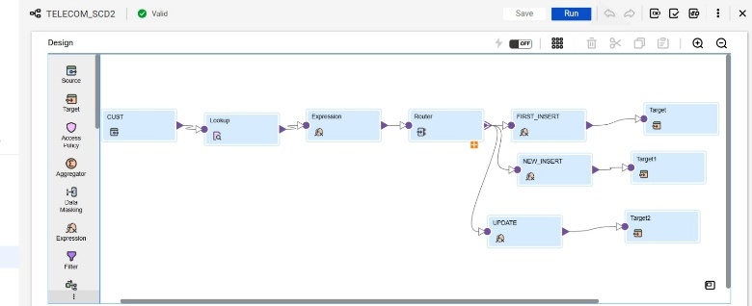
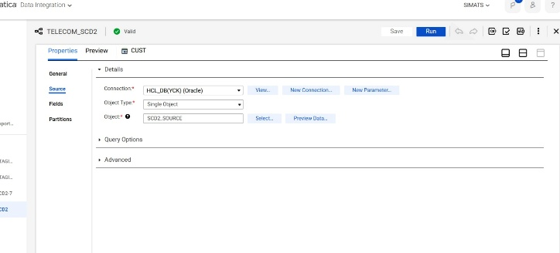

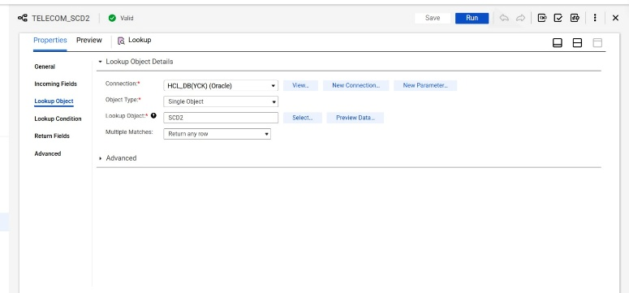

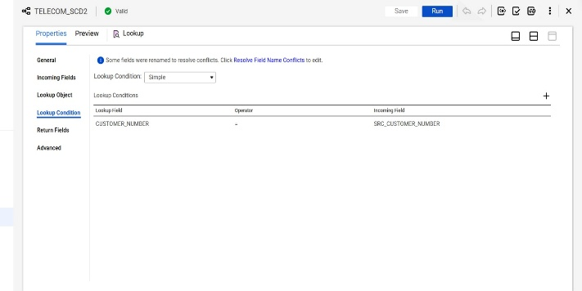
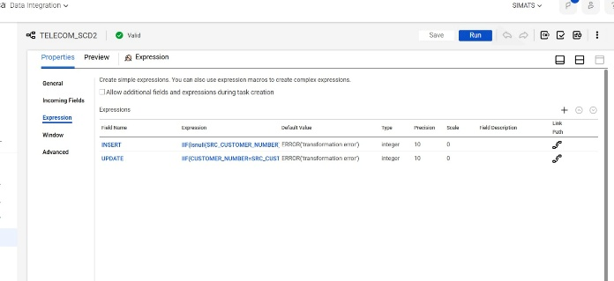
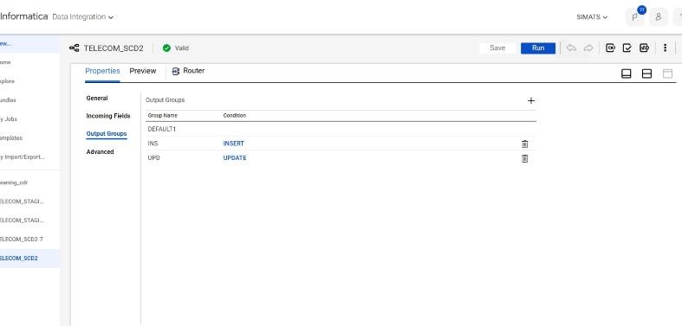

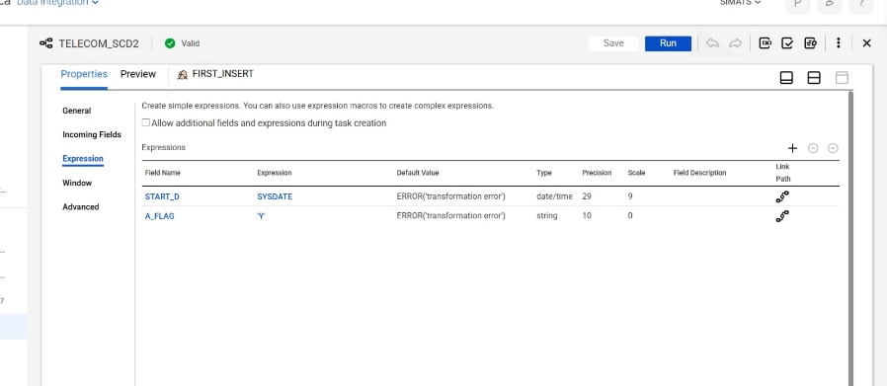

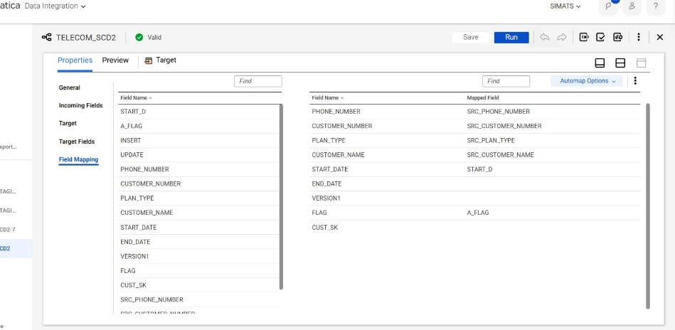
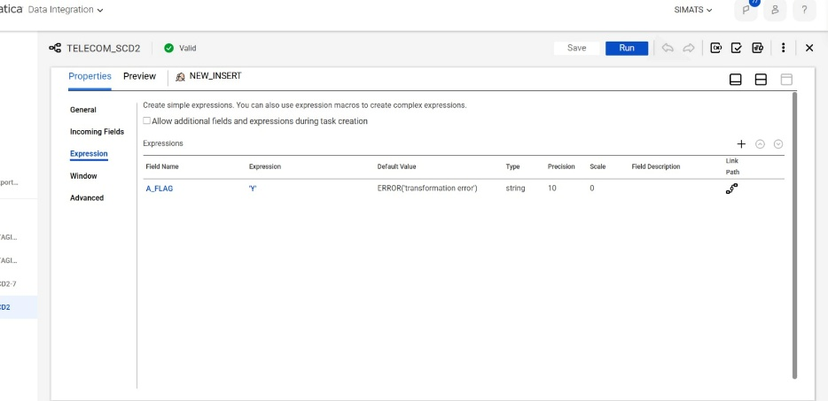

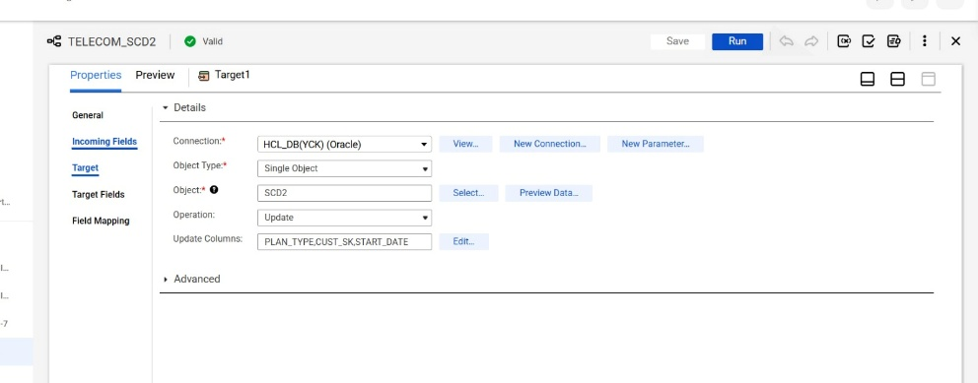
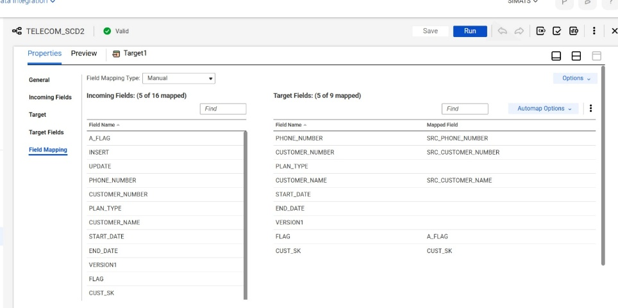

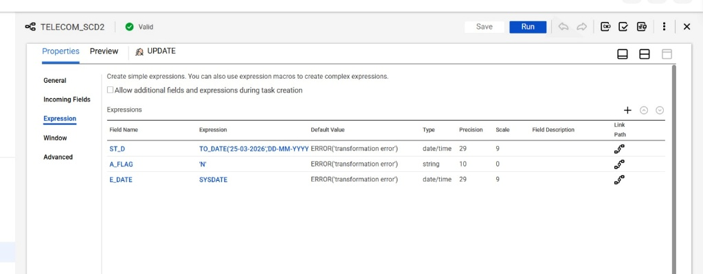

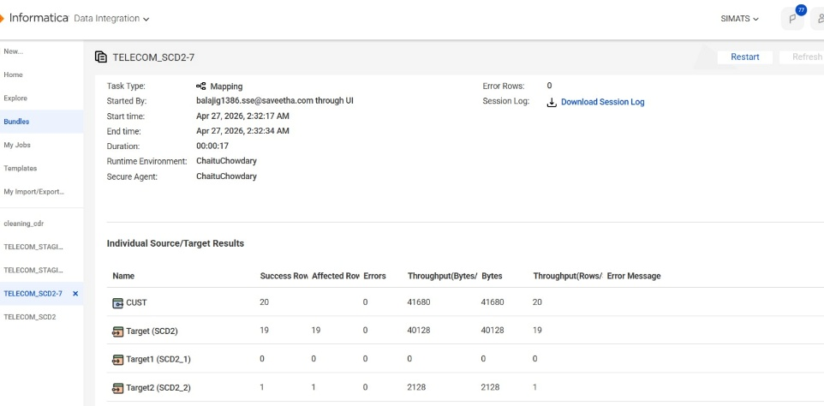

KPI 1: DAILY CALL VALUE SUMMARY
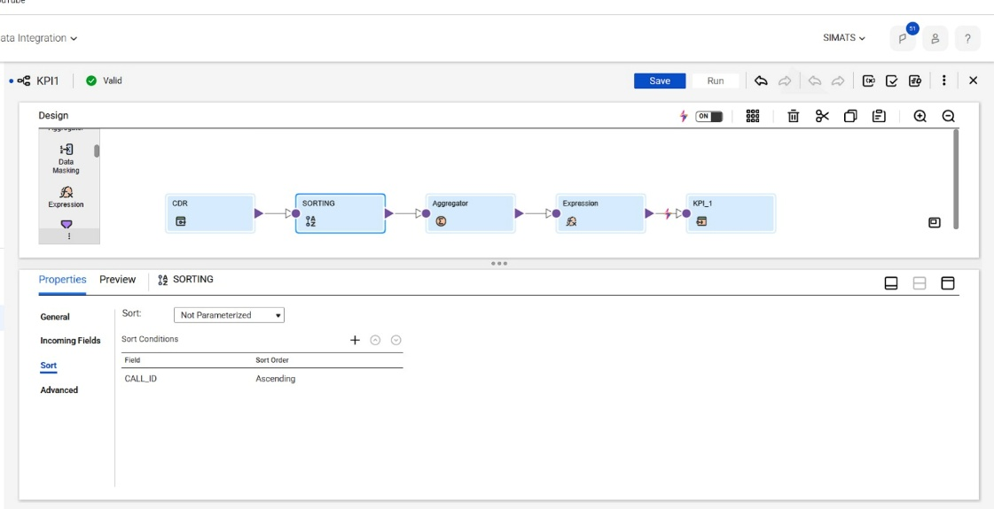
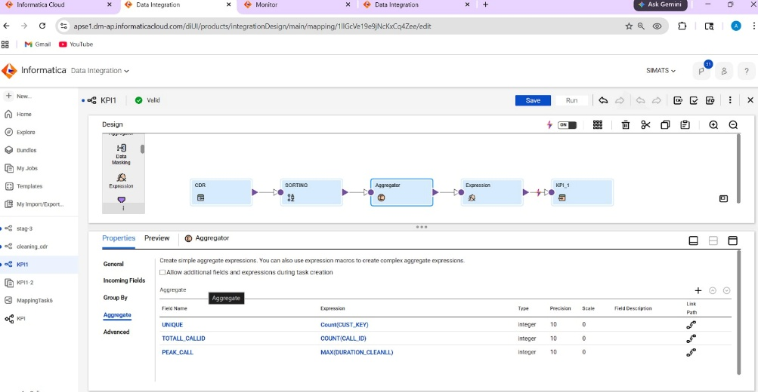
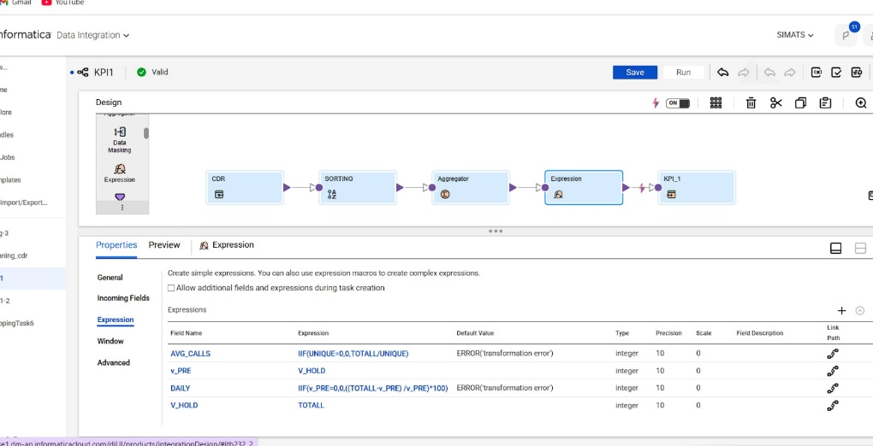

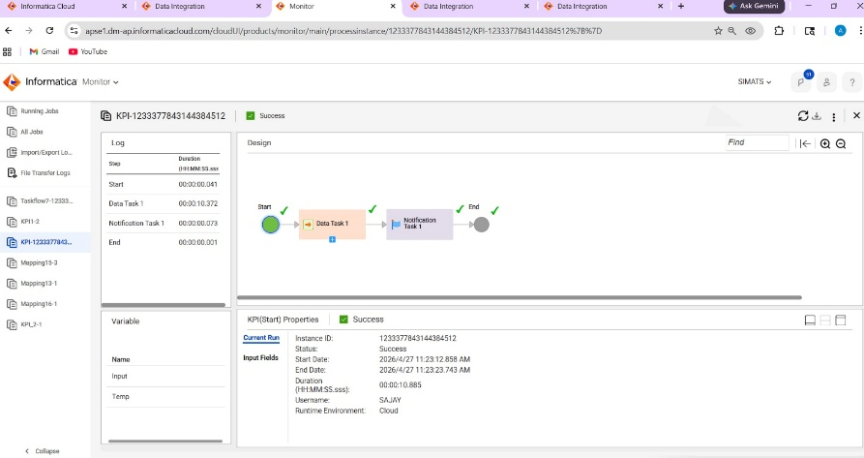

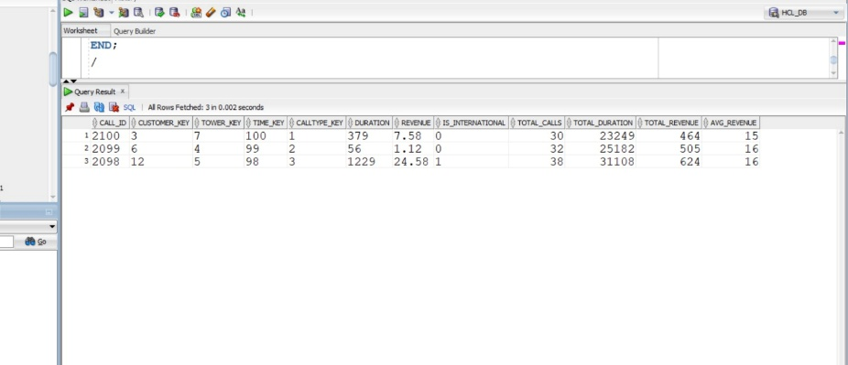

KPI 2 : CALLTYPE PERFORMANCE ANALYSER

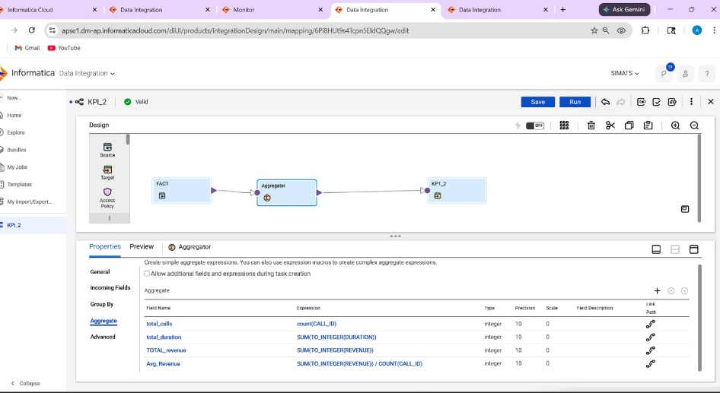
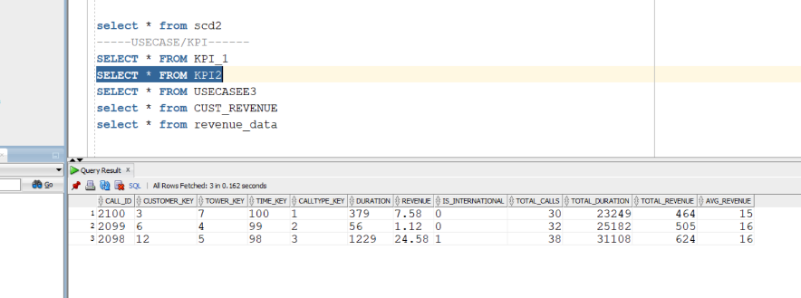
KPI 3: INTERNATIONAL CALL MONITORING
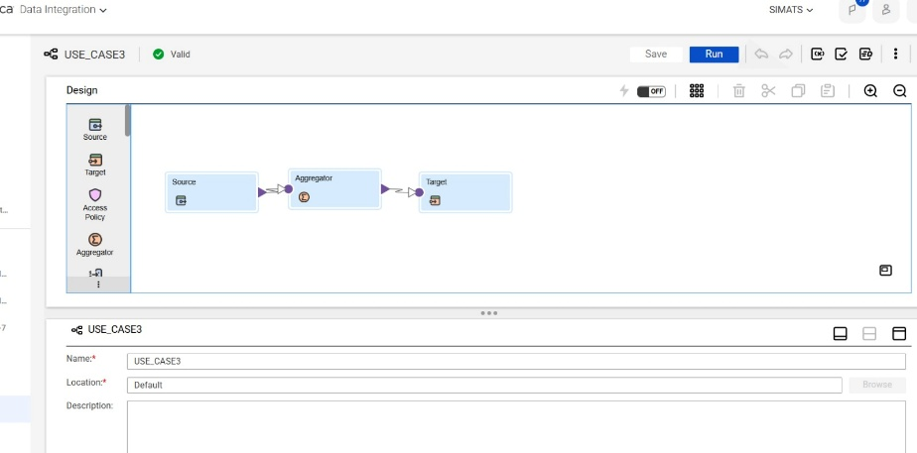
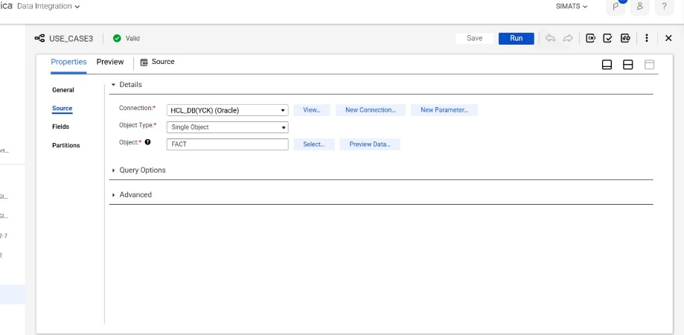
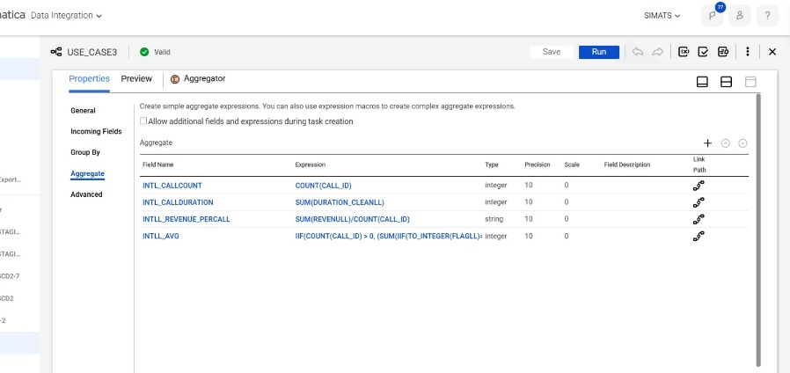
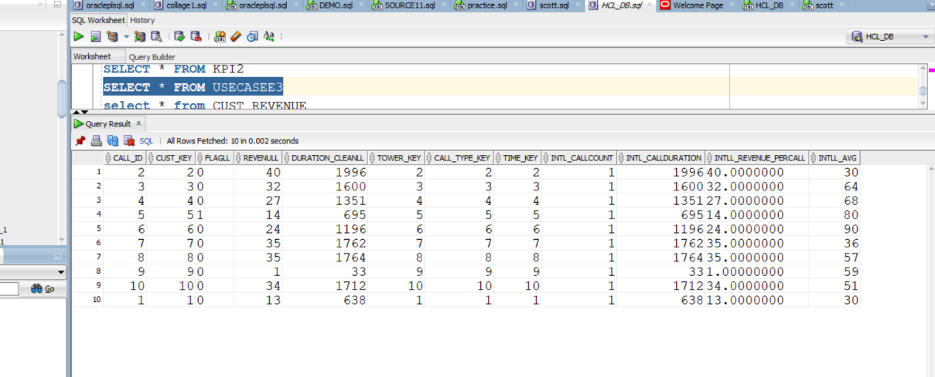

KPI 4: REVENUE DATA
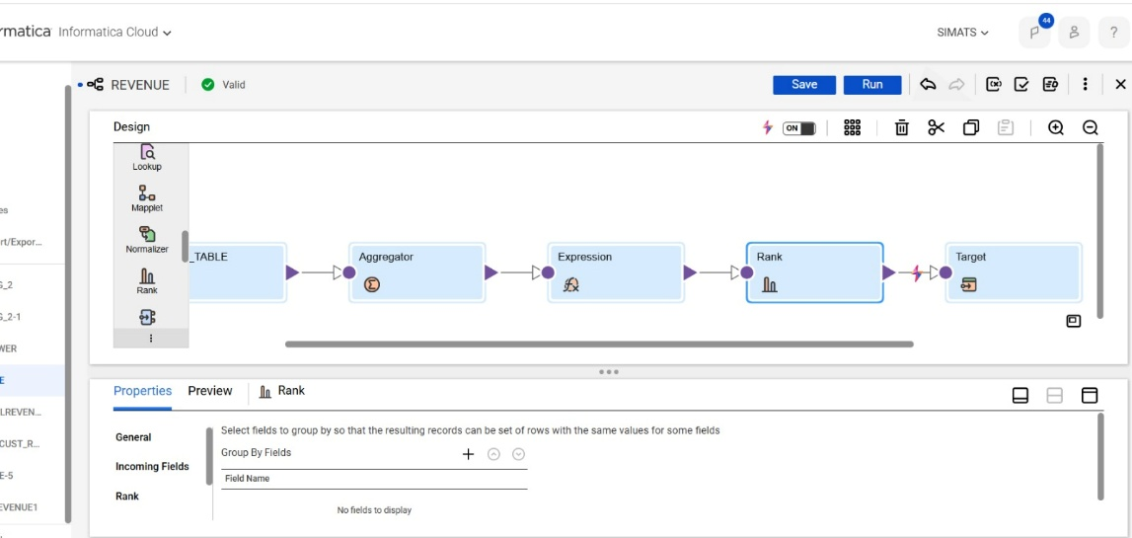
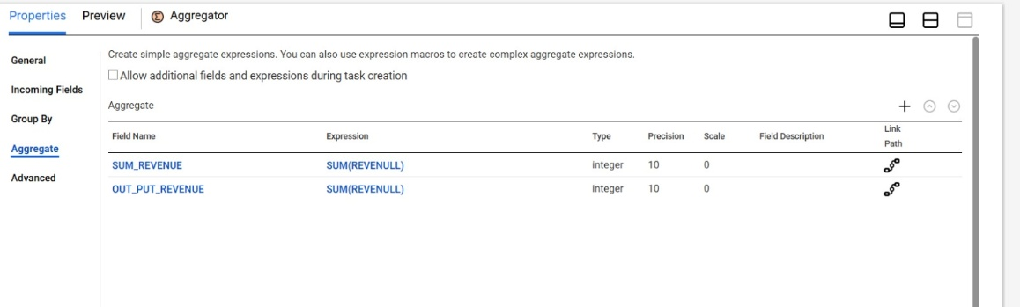
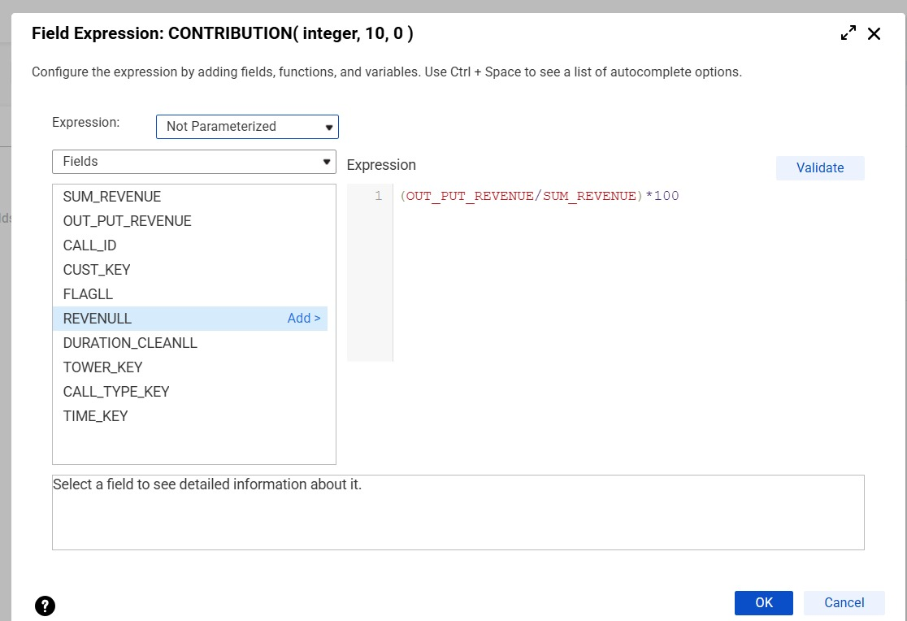
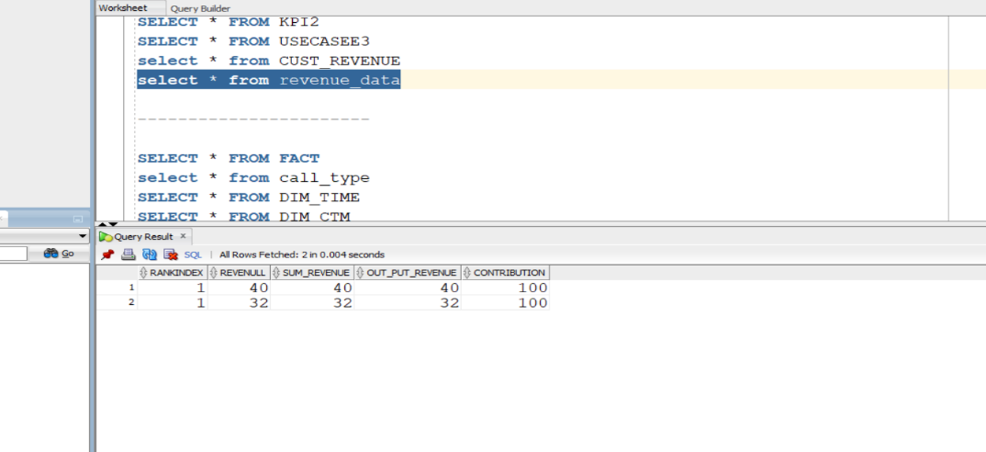
KPI REPORTINGS:
KPI 1:
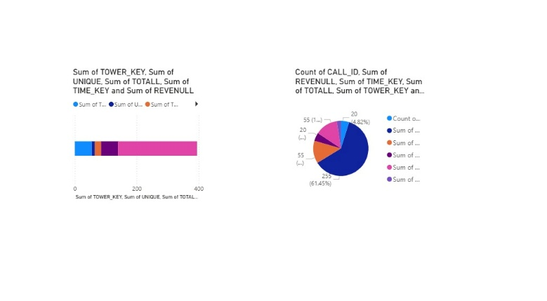
KPI 2:
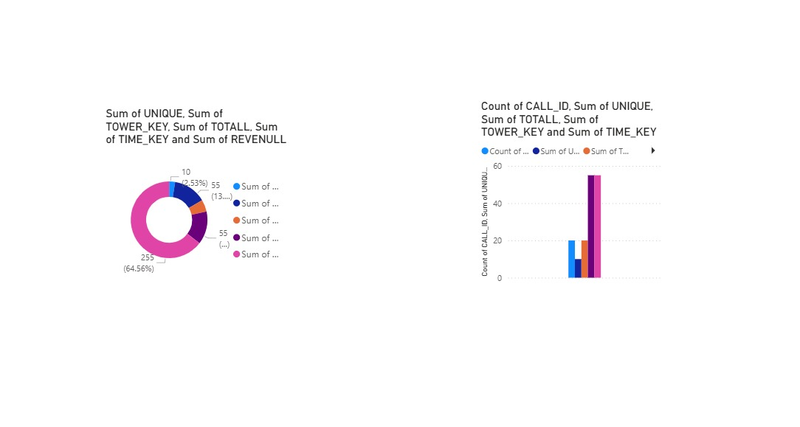
KPI 3:
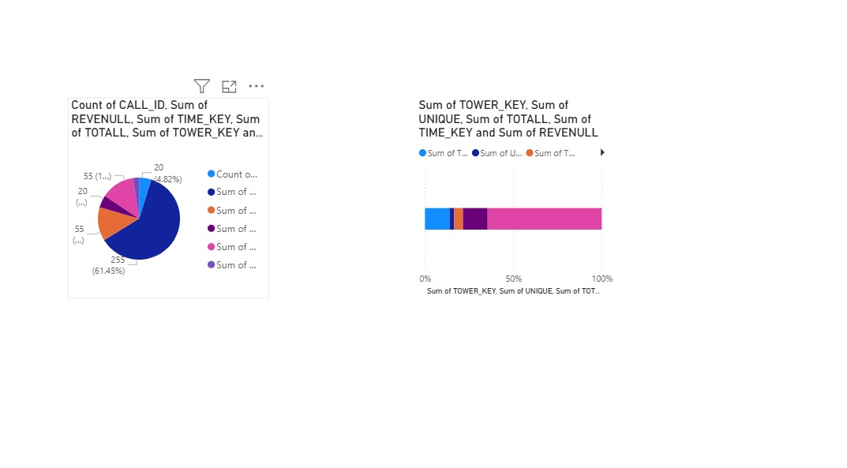

KPI 4:
